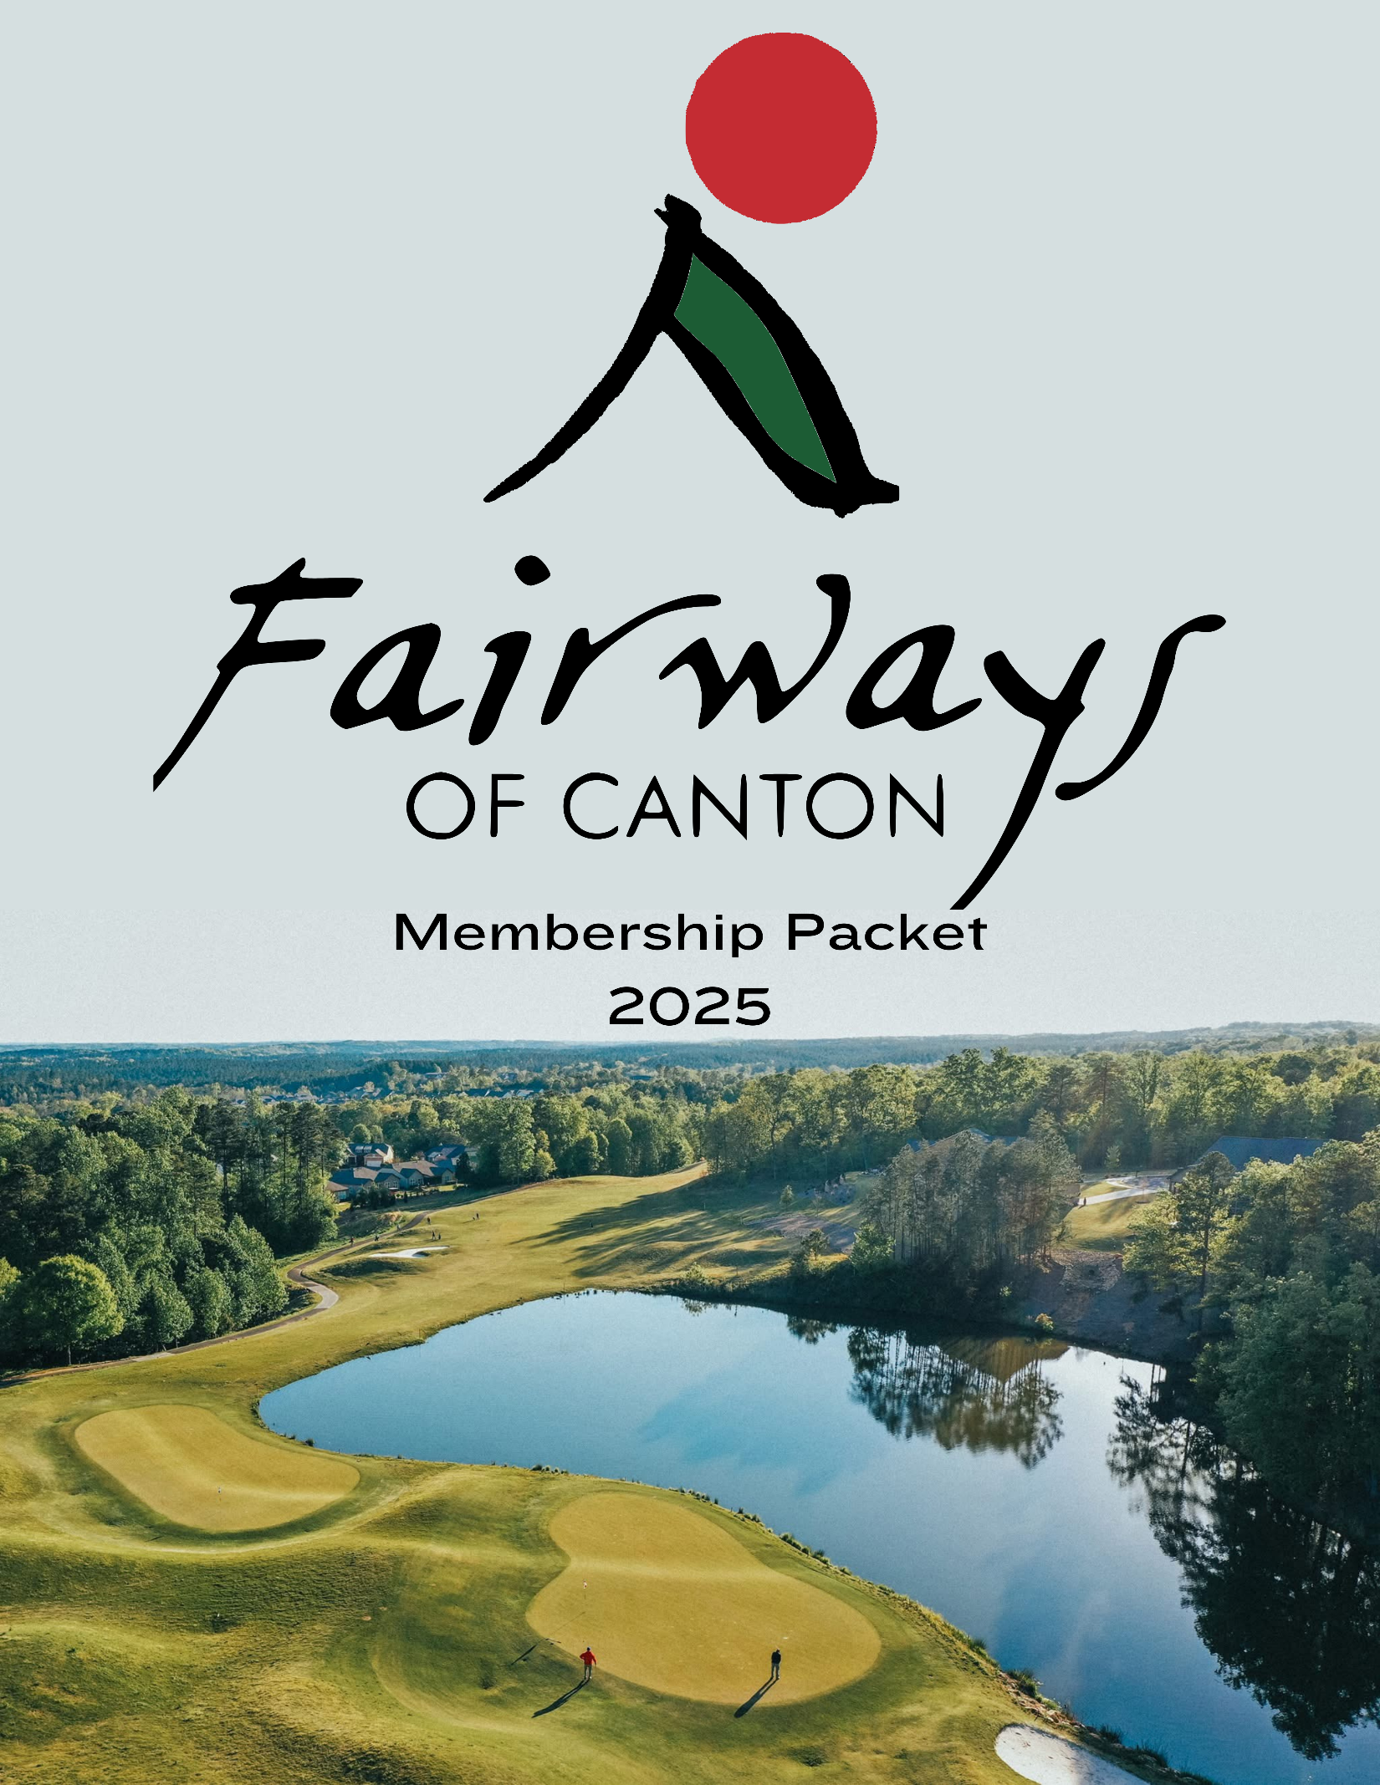

Course Information
The course layout at our facility is one of the highest qualities. Fairways of Canton takes players on a journey through 18 holes and 6500 yards of play. The course is a par 72, and it features some of the best views in the region. Be warned — this is not a course that can be overpowered. Many fairways are generous, and most greens are on the smaller side with numerous chipping areas to assist you if you miss a green or two during a round. Our greens are the only Ultra-Dwarf Bermuda Greens at any public golf course in the area. Correct placement on greens is pivotal to good scoring.

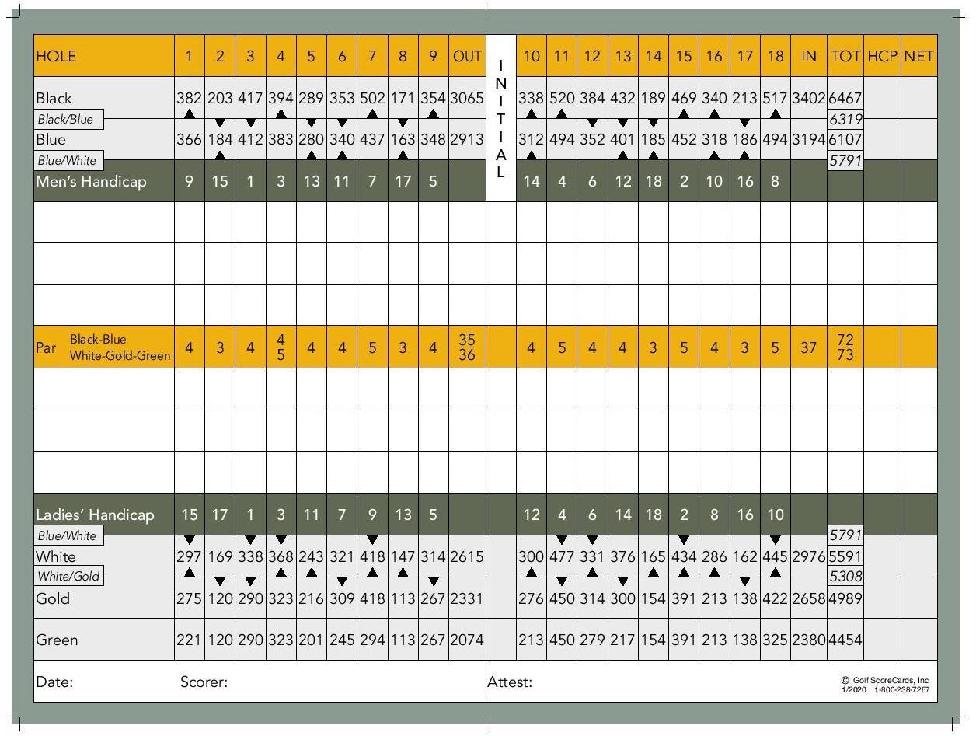

Rating / Slope
Black – 72.1 / 133 | Blue – 70.2 / 129 | Men | White – 67.8 / 122 | Gold – 64.2 / 116
Blue – 76.4 / 138 | White – 73.7 / 133 | Women | Gold – 69.6 / 121 | Green – 67.5 / 118

Membership Options

____________________________________________________________________________________________________________

Unlimited Membership
Family - $396 a Month | Individual - $342 a Month
Unlimited Golf Year-Round | Driving Range | Practice Greens
$35 a Month Food & Drink Minimum | $500 Initiation Fee | $35 Quarterly Range Fee
10% Off Pro Shop | Green/Cart Fee Included | 10% Off Stratus Restaurant

Full Membership with Trail
Family - $360 a Month | Individual - $330 a Month
Unlimited Golf Year-Round | Driving Range | Practice Greens
$35 a Month Food & Drink Minimum | $500 Initiation Fee | $35 Quarterly Range Fee
10% Off Pro Shop | Use of Personal Cart on Course | 10% Off Stratus Restaurant

NOTE- If you aren’t a member, you may not take your cart on the course. You MUST use our carts and pay a cart fee. Unlimited Golf Year-Round is subject to availability. Up to 3 dependents per acct.

Social Membership
Family/Single
$100 (Minimum per month)
May use membership in Stratus Kitchen and Bar or The Fairways Pro shop|10% off on food and beverages| 10% Pro shop purchases| No golf membership needed| 10% off does not apply to rounds of golf or range balls| Convenience of dining and charging to house account which is billed monthly

___________________________________________________________________________________

Junior Membership
Single
(18 & under)
$125 per month
Golf year round for the Junior solo or with the accompanying parent after 12pm| 1 bucket of range balls daily| 10% off in Stratus| 10% off in pro shop| ½ off play to the accompanying adult or cart fee for eligible driver

NOTE- Alcohol purchases do not qualify for 10% off
Membership for the Junior only (Parent may not use discount to play without the junior)

Public Rates

____________________________________________________________________________________________________________

Monday – Thursday
9 Holes - $44 | 7:00 Am – 5:00 Pm | 18 Holes - $59
9 Holes - $39| 5:00 Pm – 7:00 Pm | 18 Holes - $39
____________________________________________________________________________________________________________

Friday
9 Holes - $49 | 7:00 Am – 5:00 Pm | 18 Holes - $69
9 Holes - $39 | 5:00 Pm – 7:00 Pm | 18 Holes - $39
____________________________________________________________________________________________________________

Saturday – Sunday
9 Holes - $54 | 7:00 Am – 5:00 Pm | 18 Holes - $79
9 Holes - $44 | 5:00 Pm – 7:00 Pm | 18 Holes - $44
____________________________________________________________________________________________________________

Junior
9 Holes - $19 | Monday - Friday | 18 Holes - $29
9 Holes - $24 | Saturday & Sunday| 18 Holes - $39
____________________________________________________________________________________________________________

Discounts

10% - Seniors | Students | Military | Police | First Responders
____________________________________________________________________________________________________________

NOTE - Rates and hours may be adjusted due to daylight savings time.

Candidate Information
Primary Candidate
Preferred Name | Jr. Sr. Other. | Date of Birth
Home Address
City State Zip Code
Home Phone Cell Phone
Email Address
Marital Status| Single or Married
Spouse | Significant Other
Preferred Name | Jr. Sr. Other. | Date of Birth
Email Address Cell Phone ________________________
_____________________________________________________________________________
Yes, I / We have dependents as indicated below. | No, I / We don’t have dependents.
Names of Dependents-Must be 18 years or younger Date of Birth Charge Privileges
- | Yes | No|
- | Yes | No|
- | Yes | No|
_____________________________________________________________________________ Membership Type
  - | Unlimited Family Membership | $396 / Month |
  - | Unlimited Individual Membership | $342 / Month |
  - | Full Family Membership with Trail Dues | $360 / Month |
  - | Full Individual Membership with Trail Dues | $330 / Month |
  - | Social Membership | $100/Monthly Min |
  - Junior Membership | $125/Month |
_____________________________________________________________________________
MEMBERSHIP DIRECTOR MEMBER
Name: ___________________________ Name: _________________________Date___________

Signature: Signature: _____________________________________

Credit Card Information

I / We wish that our monthly charges (as defined below) be billed to the credit card indicated below.
I/We agree to a 3.5% fee added to our membership if we choose to keep a credit card on file as primary payment.
I / We agree to pay my/our membership account, including all dues, fees, applicable taxes, and all charges made to my/our account (“monthly charges”) in full each month. I / We hereby authorize the club to submit my/our monthly charges to my/our credit card indicated below. I / We understand if any amounts are rejected by the credit card company, I / We agree that a late charge up to the maximum amount allowable by law, or other penalties, may be assessed for past account dues, as provided for in the Bylaws and Rules and Regulations of The Fairways of Canton Golf Club, as amended time to time. In addition to the late fees, penalties may include, but are not limited to suspension of club privileges and/or expulsion from membership. Payments on the delinquent accounts apply first to reduce late charges and accrued dues, then to food and beverage charges, then to other charges. I / We agree to pay all reasonable collection fees, attorneys’ fees, investigation fees, and any other costs in the event this account is turned over for collection.

I / We hereby authorize The Fairways of Canton Golf Club to submit my/our monthly charges to my/our credit card(s) indicated below. This authorization shall remain in effect until revoked in writing and delivered to the club.
Charges occur on the 1st day of each month automatically.

| Master Card | Visa | American Express | Discover Card |

Credit Card Number: Ex. Date:
Cardholder Name: CVV:
Signature: Date:

Billing Address:
City: State: Zip Code: Phone Number: __________

Purpose and Intent
Club operator leases and manages certain real property and the facility known as The Fairways of Canton Golf Club located in Canton, Ga. The facilities of the club presently consist of one 18-hole golf course, one food and beverage facility, and one golf shop.
Member wishes to acquire and club operator desires to grant to a member a non-exclusive license to use all or a portion of the club facilities as a member of the club upon payment for such a membership fee as club operator may establish from time to time. Such license shall be subject to the terms and conditions set forth in this agreement, the member’s application for membership of The Fairways of Canton Golf Club, as in effect from time to time.
For and in consideration of member’s payment to club operator of an initiation fee, and member hereby accepts from club operator, membership in the club on the following terms and conditions:

Terms and Conditions
Class of Membership:
Club operator hereby grants to the member a membership, constituting license to use all or a portion of the club facilities in accordance with the privileges of such class. Course reserves the right to revoke/suspend membership at the club’s discretion at any time.

Term of Membership:
The membership shall commence on the date on which the club operator approves and accepts member’s application and shall continue in effect until one year has passed or terminated as provided below. If a membership begins mid-month, we will prorate the remainder of that current month and begin full charge on the 1^{sst} of the following month. After the initial one-year agreement is fulfilled, membership will renew automatically in one-year increments. If resignation is not received during the 13th month, the membership will be automatically renewed for another 12 months, this process will continue annually. Member may voluntarily resign his/her membership by providing the club with a 60-day written notice of such intention after one year. Such resignation shall be effective on the first day of the month following the end of the 60-day period, known as the effective date of resignation. A resigning member shall continue to be obligated for monthly club fees, services, and other club fees charged and may continue to enjoy the privileges of such membership through the effective date of such resignation. If a membership is not fulfilled by the one-year commitment, you must pay the remaining membership amount to negate your contract.
A membership freeze is not allowed unless for a medical reason and must be accompanied with a doctor’s note explaining the reason, any other circumstance will be at management’s discretion. To freeze your account due to medical reasons or cancel your membership you must submit a form by the 25th of the prior month.
Forms available in the pro shop or online.
Should you cancel your membership before your year commitment has ended, you will not be able to rejoin the club for one year.

Membership Fees:
All members are required to either pay by check, credit card, cash or enroll in our ACH program by providing an account where all associated fees will be charged. Payments are processed on the second day of each month. A credit card MUST be kept on file if the above payment style has been denied. Club operator may establish “membership fees,” all of which are subject to change from time to time. Member agrees to be responsible for all charges incurred by member’s authorized users and guests in their use of the club facilities. Member agrees to pay membership fees on or before the due date of the 2nd of each month. Member understands delinquency in paying and amounts due will result in suspension of all membership privileges, including but not limited to golfing privileges, account charging, etc. There will be a $25 late fee for all bills not paid on time. Golf fees are charged on the 1st of the month as well as the previous month’s purchases. Ex. October 1-charged for September golf and any purchases made in September. If you don’t pay your monthly charges, you will have a 30-day grace period. When your membership hasn’t been paid in 2 months, your membership will be shut off until it is brought to current. If you choose to keep a credit card on file, a 3.5% fee will be added to your membership. All membership fee increases are evaluated every January.

Membership Class Change:
Membership classification that is chosen at the time of sign-up cannot be downgraded during the first 12 months of membership. The course will allow you to upgrade at your convenience, but you are not able to downgrade your membership during the first 12 months. Receipt of Club Document:
By execution below, member acknowledges receipt of the membership policies and the club rules and agrees to be bound by and comply fully with the terms and provisions of such documents, as they may be amended, and to be responsible for compliance by member’s family members and guests.
Assumption of Risks and Indemnification:
In consideration of the membership as a condition of using the club facilities, member agrees to all risks associated with the use of the club facilities, including risks associated with the use of or proximity to the golf course, and agrees to release and indemnify the club operator from and against any and all losses, expenses, liens, claims, demands, and causes of action of every kind and character for death, personal injury, property damage, or any other liability damages, fines, or penalties including without limitation, cost, attorney fees and settlements, whether or not based on the acts or omissions of the club operator, resulting from, or arising out of or in any way connected with use of the club facilities by member, member’s family members, guests, approved designees, and their family members and guests. As used in this paragraph, club operator shall include The Fairways of Canton Golf Club, their respective directors, officers, shareholders, partners, members, agents, related companies, affiliates, predecessors, successors, assigns and employees, and all persons, corporations, partnership and other entities with which they are or may in the future become affiliated. This paragraph shall survive the rumination of this agreement and membership in the club with respect to any property damage, personal injury, or death occurring prior to such termination.

Member, as a condition of the membership, and each of the member’s authorized users and guests, as a condition of the invitation to use the club facilities, assumes a sole responsibility for their personal property. Member acknowledges and understands the member shall be liable for any property damage or personal injury at the club or at any activity or function operated, organized, arranged, or sponsored by the club, which member and member’s family members, guests, approved designees, or their family members or guests may cause. If member arranges or sponsors any activity or function on the club premises, member shall be responsible for any such damage or injury even if such damage or injury was not caused by member. Member agrees that club operator may charge the cost of any such damage to member’s club account.
No Vested Interest:
Member acknowledges that in acquiring a membership, member acquires only a non-exclusive license to use all or a portion of the club facilities, in accordance with this agreement and the membership policies and in common with such persons, including, without limitation, the general public, as club operator may authorize from time to time. Member acknowledges that a member acquires no ownership or vested rights in or to the club facilities or club operator and does not have any right to participate in the management or control of the club operator or club facilities.
Transfers and Assignments of Membership:
Member acknowledges that the membership conferred hereunder may not be pledged or assigned and is not transferable, unless and except as otherwise specifically set forth in the membership policies.
Updated Contract Information:
Member agrees to maintain current email address on file with the club and regularly check it and the club’s website for news and information. Member acknowledges that the member is acquiring a membership for the sole purpose of obtaining social benefits and recreational use of the club’s facilities and not as an investment or with any exception of making a profit from the ownership or future transfer of membership. This agreement shall not be binding unless and until the member’s application is approved and accepted on behalf of the club operator as provided therein and this agreement is executed below by the club operator.

Course Rules

The course rules are designed to enrich the experience each member has while at the course. Failure to adhere to the course rules can result in suspension and/or termination of membership. It is each member’s responsibility and obligation to read,
understand, and follow all course rules.

Members must make Tee Times
The Fairways of Canton Golf Club tee times are for the benefit of the members as well as the course. Please remember that members are afforded access to tee times 14 days in advance when available.

The Fairways of Canton Golf Club staff will do their best to accommodate walk-ins after those who scheduled tee times.

Delinquent Members will lose all Membership Privileges
Members who are more than 60 days past due will lose their ability to:
Charge their account | Enjoy complimentary range balls | Play golf at their respective rate.

Members must Check-In with the Pro-Shop Before Play
Checking in with the pro-shop allows the course to develop accurate reports and helps ensure all players on the course are accounted for.

Complimentary Range Balls are for the Member and Not the Member Guests
At no time is it permissible for members to give range balls to guests. Range balls are for the range not the course. If we see anyone with range balls on the course, playing, they will be charged a fee of $25. Range balls are for the range.

All Play must Commence on Hole 1 unless Permission is Granted by the Pro-Shop
On occasion players will be asked to start on hole 10 for that day.

In witness whereof, club operator and member have caused this agreement to be executed on their behalf.

Membership Director Member

Name: Name:________________________

Signature: Signature:_____________________

Date:____________________
Any membership cancellations must give a 60-day notice to Membership Director unless member has fulfilled the 1-year contract. The same rule goes for renewed yearly contracts as well.

______________________________________

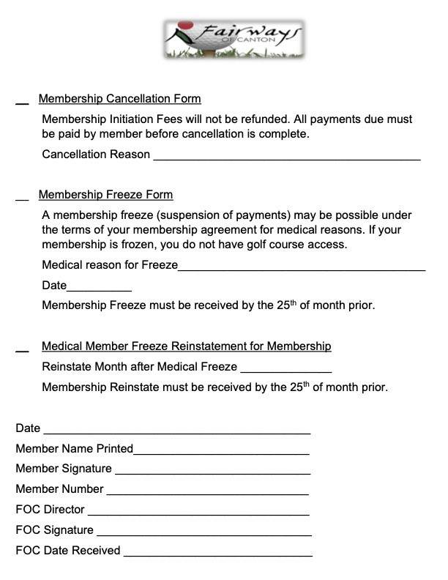
Any membership cancellations must give a 60-day notice to Membership Director unless member has fulfilled the 1-year contract. The same rule goes for renewed yearly contracts as well.
______________________________________

